Adding a Host in Nagios

**Adding a Host in Nagios**

**Commands with green font represents master, white font terminal represents slave.**

**Installing NRPE on slave:**

**Step 1:** On slave run the following command.

$ sudo apt-get update

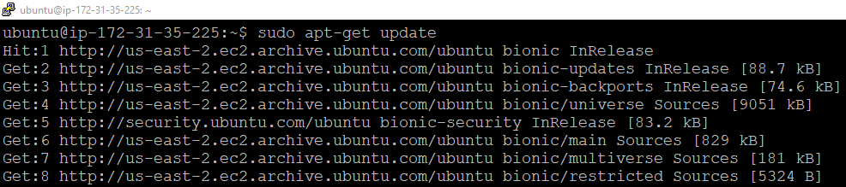

**Step 2:** Install the required plugins

$ sudo apt-get install nagios-nrpe-server nagios-plugins

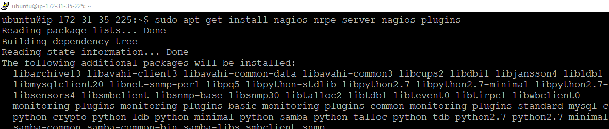

**Step 3:** Open the configuration file as shown below:

$ sudo nano /etc/nagios/nrpe.cfg

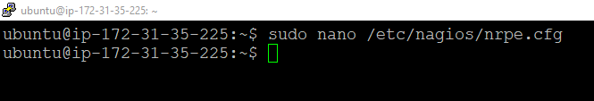

Find the below given line and in place of XXX add your **master IP**

allowed_hosts=127.0.0.1, XXX

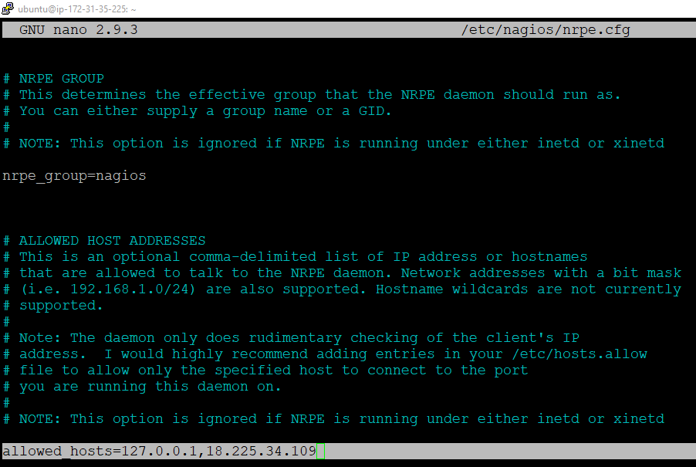

**Step 4:** Start NRPE service as shown below:

$ sudo /etc/init.d/nagios-nrpe-server restart

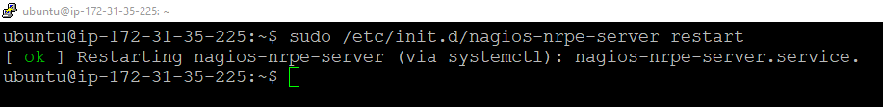

**Install check_nrpe on Master:**

**Step 1:** Now we need to install check_nrpe on Master.

$ sudo apt-get update

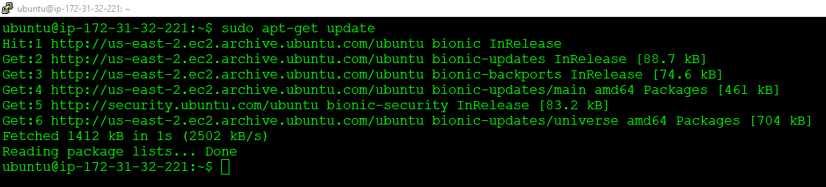

**Step 2:** Install the following package.

$ sudo apt-get install -y autoconf automake gcc libc6 libmcrypt-dev make libssl-dev wget openssl

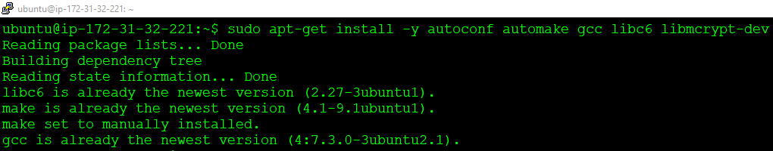

**Step 3:** Get inside tmp.

$ cd /tmp

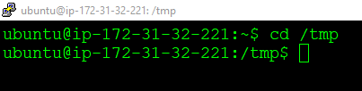

**Step 4:** Download the source.

$ wget --no-check-certificate -O nrpe.tar.gz https://github.com/NagiosEnterprises/nrpe/archive/nrpe-3.2.1.tar.gz

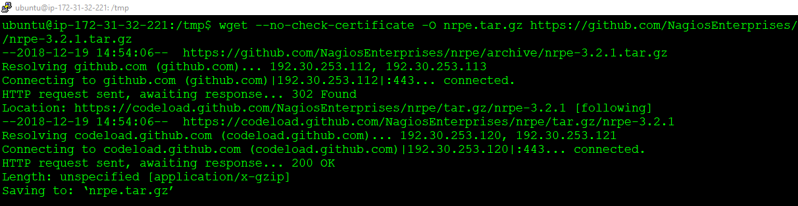

**Step 5:** Untar the file.

$ tar xzf nrpe.tar.gz

**Step 6:** Then execute the following command.

$ cd

$ cd /tmp/nrpe-nrpe-3.2.1

$ ./configure

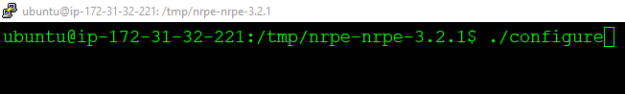

It takes some time to configure.

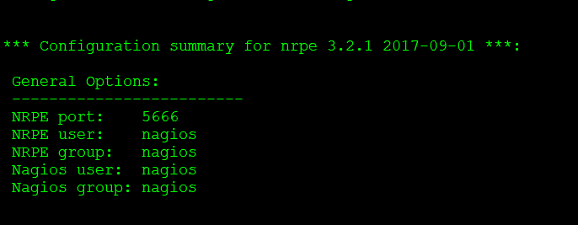

**Step 7:** Run the check_nrpe command.

$ make check_nrpe

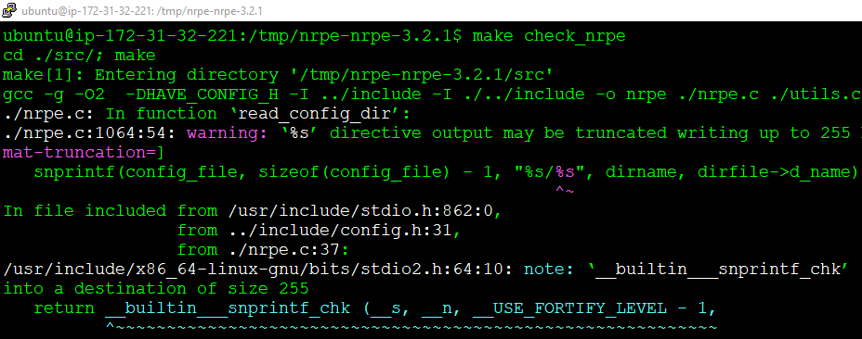

**Step 8:** Now install plugins.

$ sudo make install-plugin

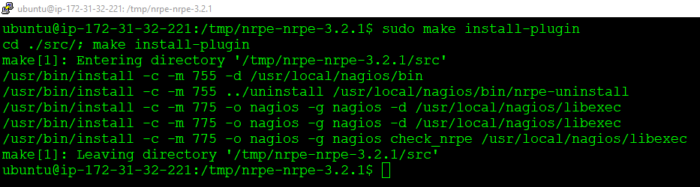

**Step 9:** We will check the connection as shown below:

$ cd

$ /usr/local/nagios/libexec/check_nrpe -H <SlaveIP>

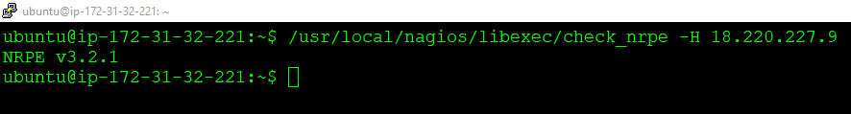

Now we need to make the following configuration file before we observe the connection.

**Step 10:** Make a configuration file as shown:

$ sudo nano /usr/local/nagios/etc/servers/MyHost01.cfg

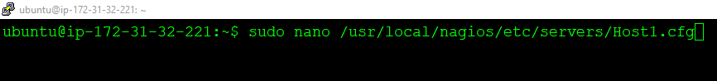

Add the below given content there.

#########################################################

# Linux Host 001 configuration file

#########################################################

define host {

use linux-server

host_name Linux_Host_001

alias Linux Host 001

address <slaveIP>

register 1

}

define service{

host_name Linux_Host_001

service_description PING

check_command check_ping!100.0,20%!500.0,60%

max_check_attempts 2

check_interval 2

retry_interval 2

check_period 24x7

check_freshness 1

contact_groups admins

notification_interval 2

notification_period 24x7

notifications_enabled 1

register 1

}

#########################################################

# END OF FILE

#########################################################

After adding the content, the configuration file should look like this:

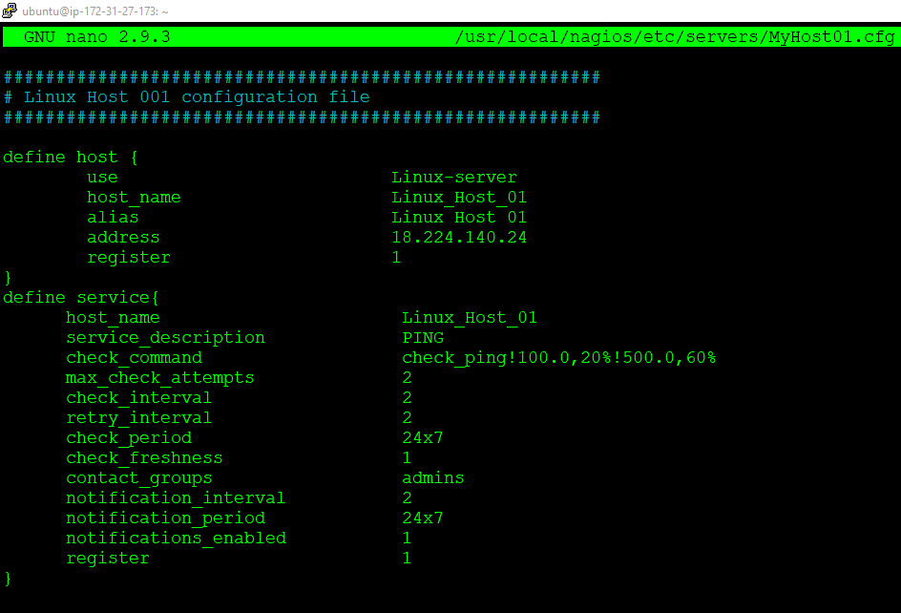

**Step 11:** Now verify the configuration again.

$ sudo /usr/local/nagios/bin/nagios -v /usr/local/nagios/etc/nagios.cfg

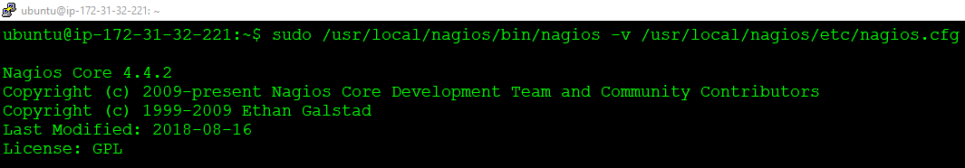

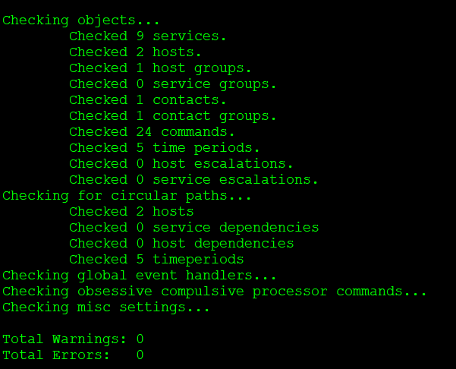

Everything looks fine!

**Step 12:** Start Nagios.

$ sudo service nagios restart

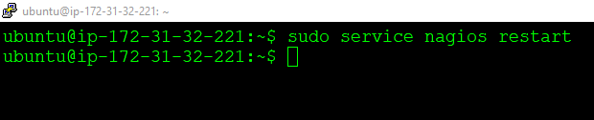

**Step 13:** Go to the browser. And you can see the slave is added to the connection with a PING service running.

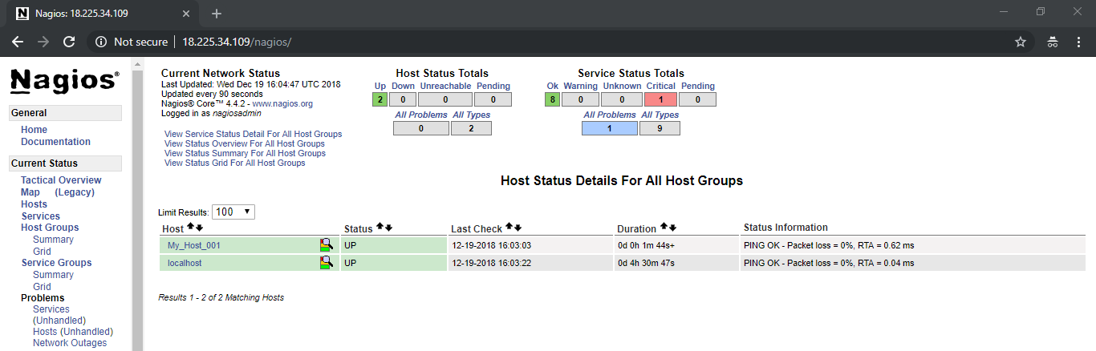

To see the connection map, click on **Map.**

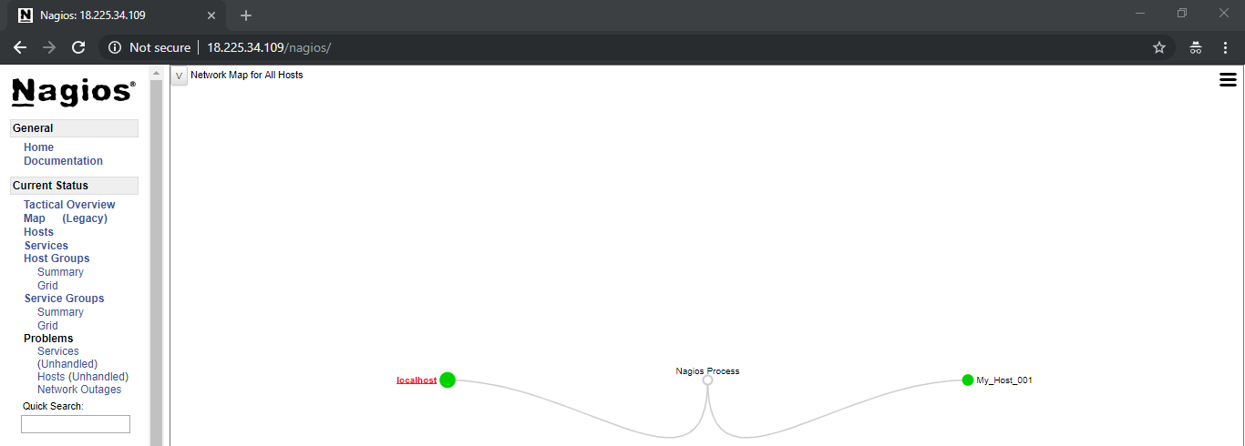

**Congratulations!** You have successfully setup Nagios Master-Slave Cluster.